Skill Lab - Ist Year – Simulation using LT Spice Software - 2024

Experiment-3;-Simulation of half wave rectifier circuit with filter using LT spice.

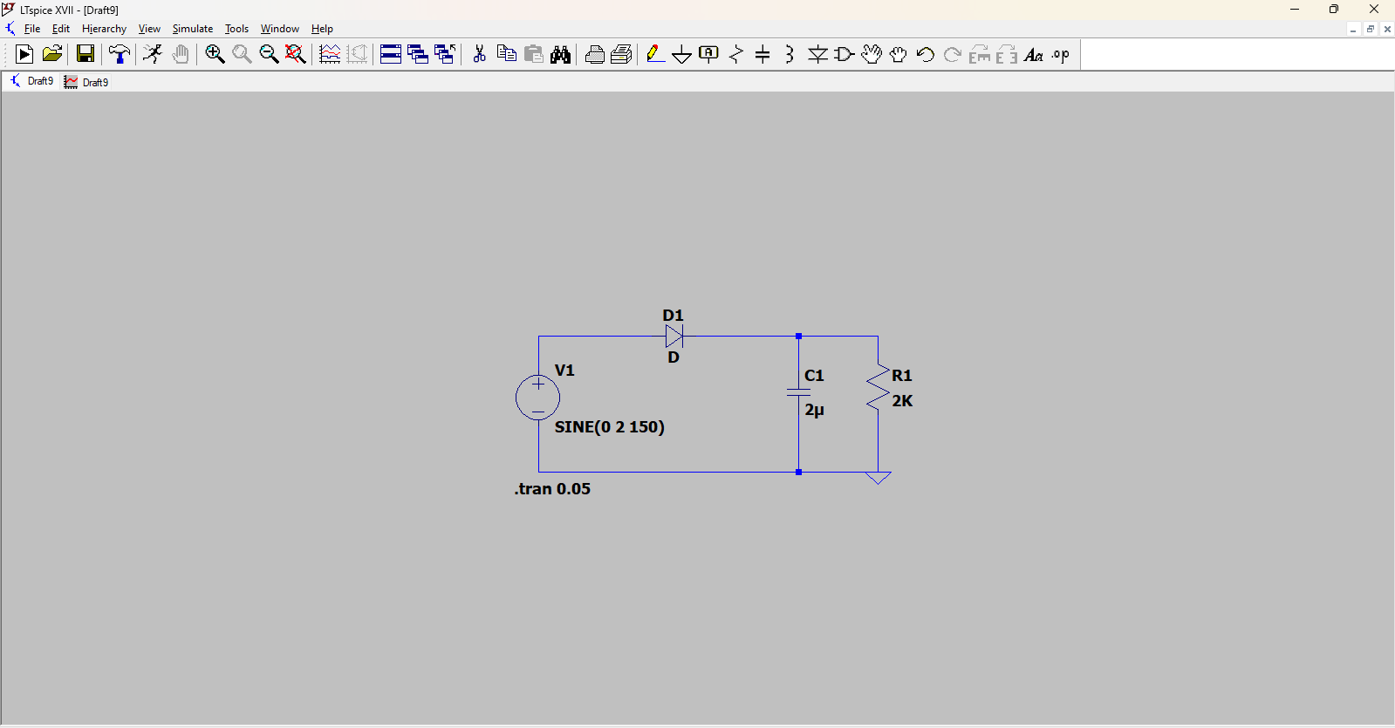

Components used

1 Resistor

2 Battery

3 Wire

4 Diod

5 Capacitor

WORKING ;- A half-wave rectifier converts an AC signal to DC by passing either the negative or positive half-cycle of the waveform and blocking the other. The filter capacitor is a type of capacitor that is used to remove a particular frequency or series of frequencies from an electronic circuit

Graph

Input=blue

Output=green

